Why Art and Creativity are at the Center of Curriculum in Early Childhood?
By
Dipanwita Ray
M.Ed. (Student Researcher) & Early Childhood Educator
University of South Carolina,
Columbia

Abstract
How do children learn and express themselves? How do children think? What role do imagination, thinking, and cognitive development play in learning Art and Creativity during early childhood? I believe Art and Creativity are interconnected and the creative development in children is expressed through their artistic abilities. Art is all about process and not product in children. Creativity enhances Art, building on their imaginations. This paper explores how Art starts with scribbling and scratching among toddlers and transforms into drawing, painting, and coloring in the early childhood period. Creativity is one’s own expression and continues throughout one’s life. Thus, Art is how children express themselves when they are actively involved in their own learning. Some other forms of Art are expressed in Music, Acting, and Play in children. This makes Art and Creativity the center of curriculum during the early childhood period. “For creativity to flourish in an educational setting, it is necessary for learners to be actively involved in the process of their own learning” (Prentice, 2000).
Introduction
Have you ever noticed how engaged and happy children are during the process of making Art when you give them some paint and a brush? A child’s first experiences with Art are always full of pleasure, imagination, and active participation. This engagement in Art is creativity. It sparks children’s interest and helps them in their ability to think and imagine. What is the definition of Art? What are the values of art for young children? In Art, we see the joy of children which keeps them motivated and helps them to perform, create, and think to the best of their abilities. Art is the freedom to explore and experiment with colors and tools.

What is Art?
Art is the creativity and exploration of one’s ideas. Art brings out the expressive side in children by capturing their imagination. Art is the freedom to appreciate the elements in nature. Art is a colorful journey for children that allows them to expand their minds and think about how to create an original piece of work that is so exclusive. I mentioned the word original since every child’s art is different, based on their own imagination and choice of how and what they want to create. Art is an expression of what is in their minds, and it is their ability to see things in different ways.
What is Creativity
Creativity is in the process, rather than in the product. The process, and not the final product, is what matters in children’s art and how their creativity is expressed. Thus, the essence of creativity lies in the journey taken to make every masterpiece. “Creativity is not a linear process, in which you have to learn all the necessary skills before you get started. It is true that creative work in any field involves a growing mastery of skills and concepts. It is not true that they have to be mastered before the creative work can begin” (Robinson, 2015).
In the child’s eye, creativity starts with lines, circles, shapes, or symbolic representations of objects, animals, and people. Give a child a blank paper with a marker or crayon and watch how their interest is sparked and how their creativity begins with zigzag lines, scribbling, and uneven circles, each having some symbolic representation such as the sun, moon, star, and so on in a child’s mind.
Representation of figures and symbols in Art among children
I have observed children in multiple Art classes ranging in age groups from toddlers to 3rd graders. What I have learned during my observations and interactions with them is that for most children, Art during the early years is just a representation of shapes, lines, figures, and circles while they are exploring and trying to find out what they can make with them. Striving for realism comes much later as an older child learns in school. While toddlers begin with scribbling, scratching, and drawing zigzag lines, a 3-year-old a usually interprets drawing a circle as representing the sun and adding lines to make the rays. These later transforms into human figures by adding tiny circles to represent eyes and a line to represent a nose when the children are in Kindergarten or 1st grade. The long and short lines that they draw or the triangles represent hands, legs, and the body.
Children are generally familiar with shapes like triangles, squares, rectangles, and circles that are mostly represented in their drawings of houses with rooftops, windows, doors, the sun, the moon, and human beings. Gradually, gender comes in and girls tend to draw and color princesses, flowers, and rainbows while boys tend to go with drawing and coloring superheroes, racing cars, trains, and bridges. Girls generally like to paint with pink, purple, and gold, while boys prefer blue and green. Although I do not believe in color choices based on gender during the early years, this is what I have observed most children doing. They tend to show a preference for certain colors when completing artwork. What I discovered from observing children in the art classes are that they need to be given opportunities to explore and experiment. They need to be encouraged and provided with different materials such as pencils, chalk, chubby crayons, paints, markers, and more, to express their thoughts and imagination. Children need lots of opportunities to explore with different materials to expand their creativity and texture.
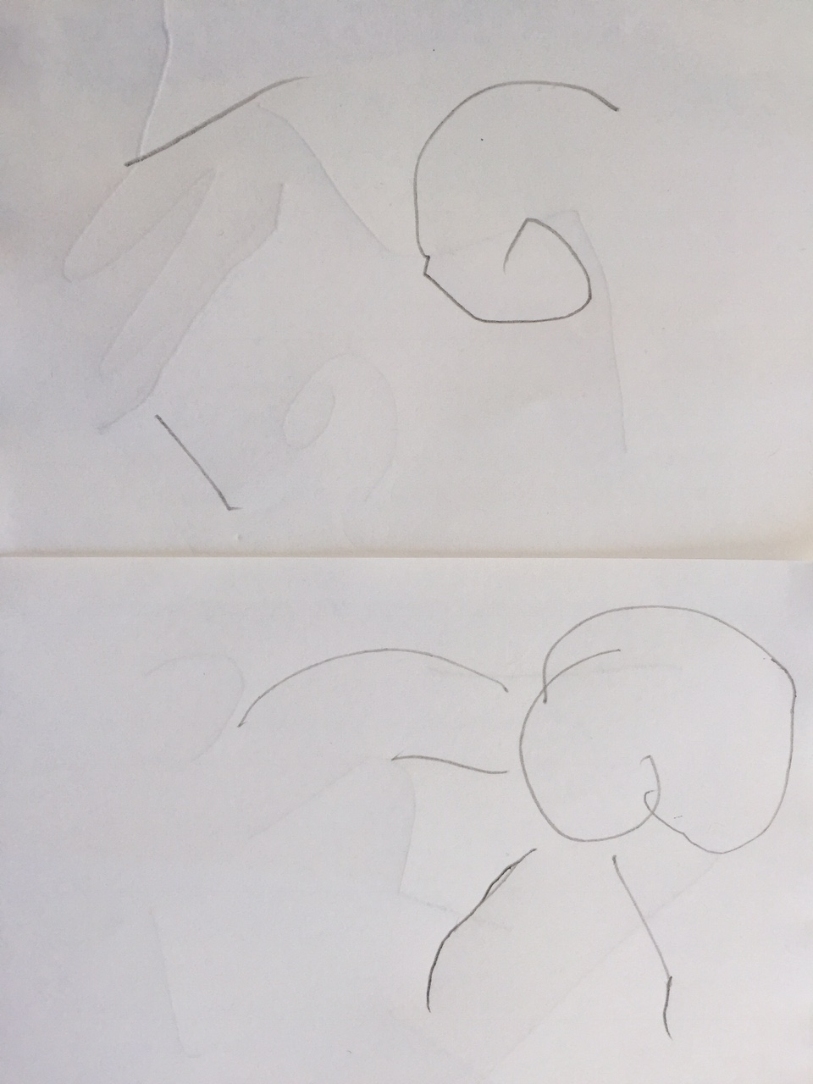
Figure 1.
This shows 2 and 3 year olds trying to draw uneven circles and how these circles later transform into a representation of the sun and its rays.
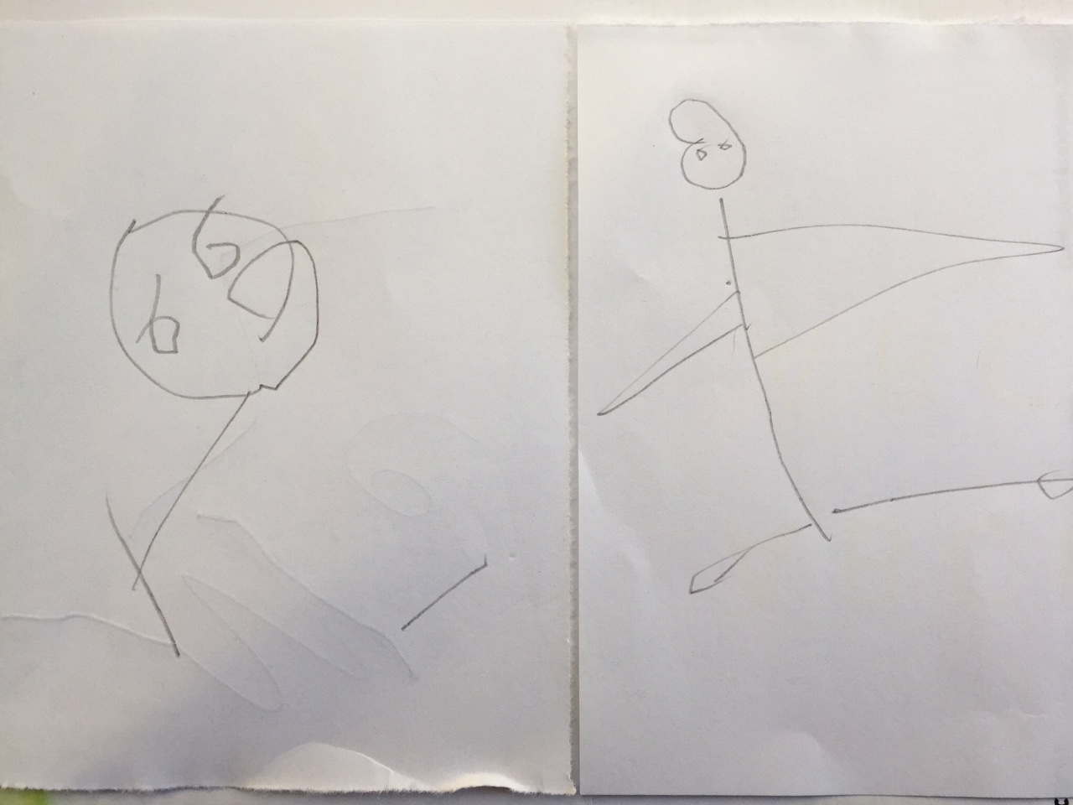

Figure 2.
This shows how children learn to draw circles and how over time, these circles transform into human beings by using lines, shapes, and triangles to add hands and legs.

Why Art must be open-ended and the importance of Play
Open-ended art activities help in play among children. When teachers respect children’s play and expressions, spontaneous play can transform into Art and this is mostly seen in early childhood curriculums. Playing with water, sand, dough, and finger painting can all transform into sensory Art. Art and Creativity are interconnected and need to be incorporated into children’s learning and thinking to plan an effective curriculum. When children engage in drawing, painting, and playing with dough, sand, and water, all of these expressions build a path to an artistic future. The curriculum in arts in early childhood mostly originates from spontaneous play. Since play is the highest form of expression and learning among children, artistic abilities are generally seen developing from play in children.

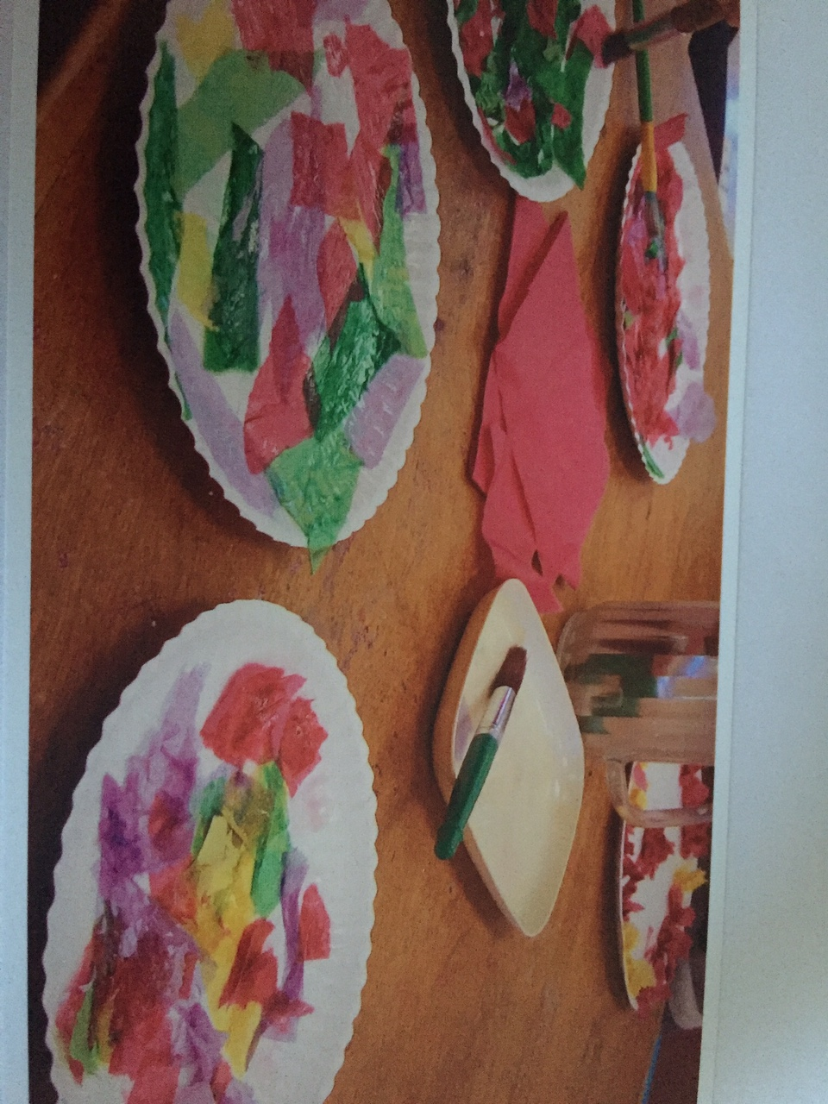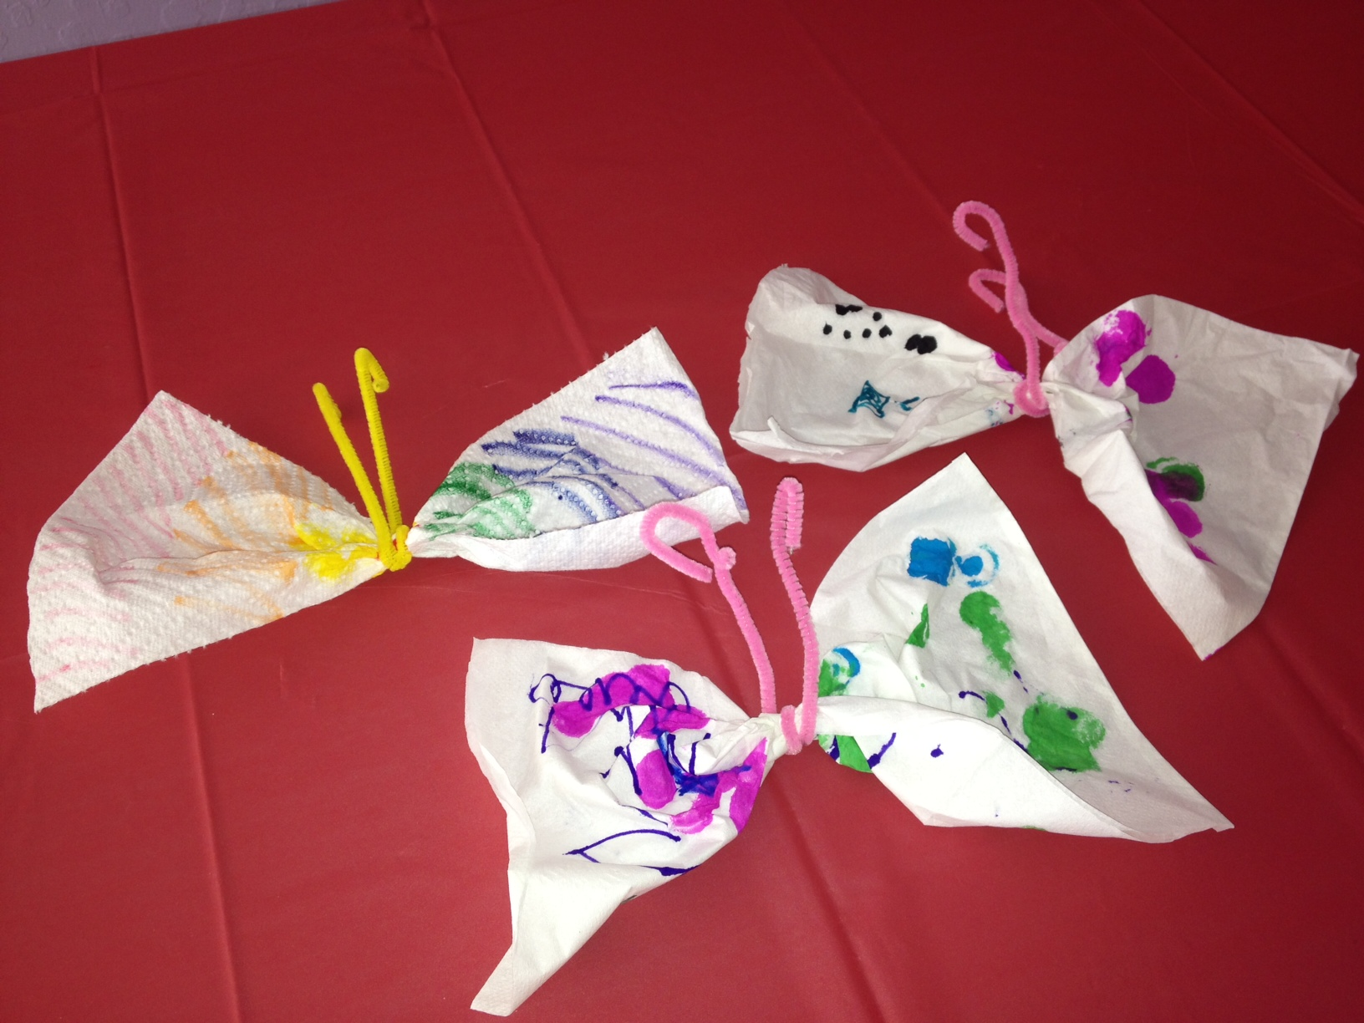
Figure 3. (a) and (b)
Examples of open-ended Art among children with (a) paper plates, tissue paper, and glue and (b) butterflies with kitchen paper towels, markers, and pipe cleaners.

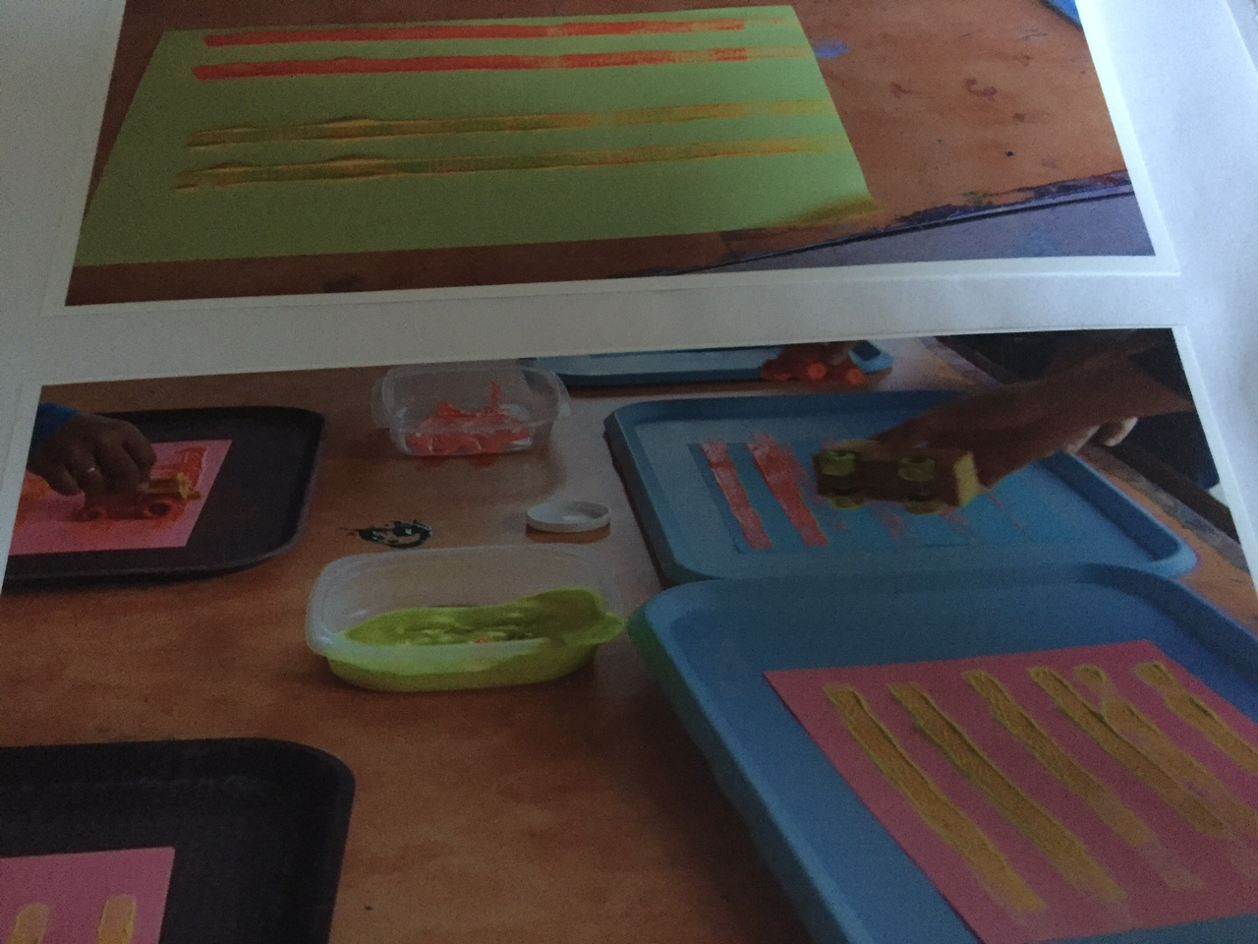
Figures 4.
This shows children’s artwork and how children learn to be creative and then expand their creativity into texture and sensory development by using a variety of materials like toys and toy cars with wheels to paint and make car tracks and train tracks. This is also an example of how children can transform play into Art.
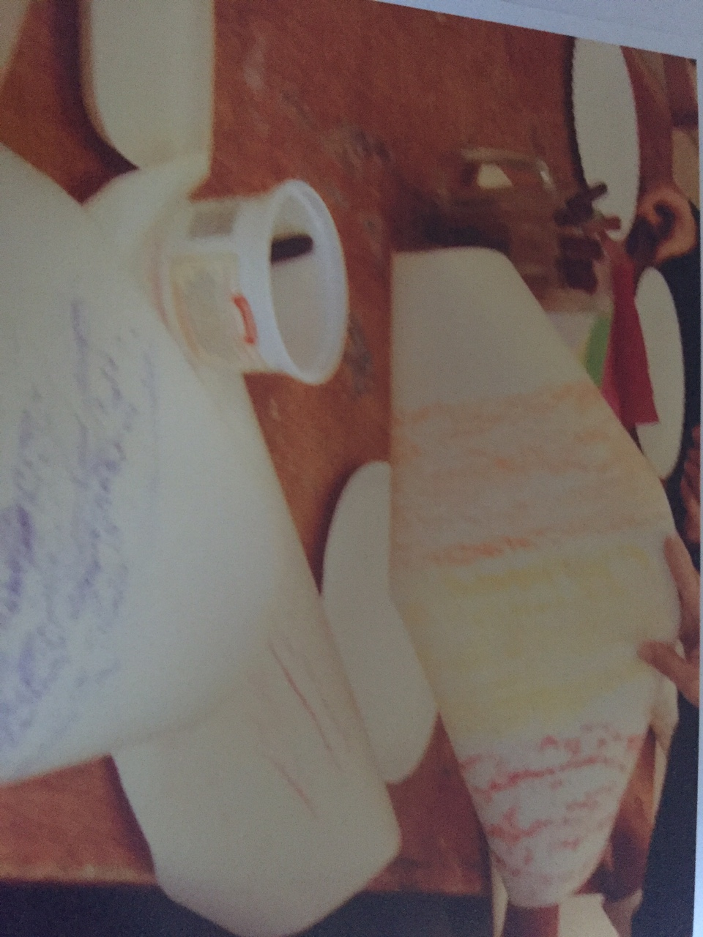
Figure 5.
This shows children’s artwork making connections with Nature by using crayons for bark impressions on paper. The work shows children exploring tree barks with crayons to draw a textured pattern.
Development in Children through Art
Research studies tell us that it is difficult to understand how knowledge is organized in a child’s mind and how it is then applied in different situations. Brain development is crucial in the first five years of a child’s life. Thus, early learning experiences and hands-on activities provide a strong base for brain and sensory motor development in children. How well these functions have a direct influence on children’s creativity, expressions, learning skills, and emotional and social development. For this reason, Art is considered an important element in many curriculum areas for children. Art provides sensory motor development and small muscle skills when children are allowed to explore by using paint brushes and water. The finger and hand grips are developed when children use chubby crayons and colored pencils to sketch and color. When children are exposed to a variety of mixed-media and natural resource materials to complete their artwork, they are able to acquire skills that help in small muscle and large motor development. Thus, we must support children in their choices of mediums and allow them to explore and be open-ended when they are engaged in any artwork.
Arts Experiences among children
The progress and development of children are most vividly expressed through Art and Play. Both play and art-making require children to be creative. They offer multiple opportunities for teachers to observe children by using words, language, speech, counting, and sensory skills. Play and Art also provide good opportunities for children to share their toys or artwork, make friends, talk about their cultures, and most importantly, express their inner selves. I have seen all of these skills during my observation of children. Teachers and educators must remember that it is the process, and not the product, that should be encouraged among children when conducting art with them. Painting, drawing, coloring, finger painting, and other paint experiences encourage and invite children to experiment with texture by using their hands, palms, and fingers. Children should be allowed to use markers, pencils, chubby crayons, colored pencils, chalks, and all other materials that help in hand-eye coordination.
My Observations and Data Collection
I gave my students many different materials to explore and experiment in their art classes to make a face mask. I observed them all working hard and remaining engaged in their artwork to identify which materials they could use to make their mask. I noticed that when children were given unlimited opportunities to use a variety of mediums (such as paint, crayons, markers, beads, pipe cleaners, stickers, glitter glue, stone studs, shiny stickers, sequins, and much more) to explore, they became much more motivated and worked enthusiastically to figure out how to use all of the different materials in their artwork. Their engagement, interest, and dedication in making their artwork and owning it as their work made me realize that creating an awareness of Art in schools and incorporating Art into the curriculums is essential. I also observed that children who are generally restless in the class settled down well when they were asked to do some artwork. This shows that Art plays a huge role in focus and attention among children by making them settle down and remain engaged in the Art. Children should be encouraged to paint, color, and draw by using their hands, fingers, arms, and even their feet. I suggest using some excellent natural resources and recycled materials to conduct artwork with children. Some examples include egg cartons, brown paper bags, brown wrapping paper, newsprints, old magazines, kitchen paper towels, aluminum wraps, coffee filters, small burlap rolls, rocks, shells, dried flowers, and leaves. The role of the teacher should only be that of a facilitator and the artwork must reflect the children’s own expressions, thoughts, and imaginations.

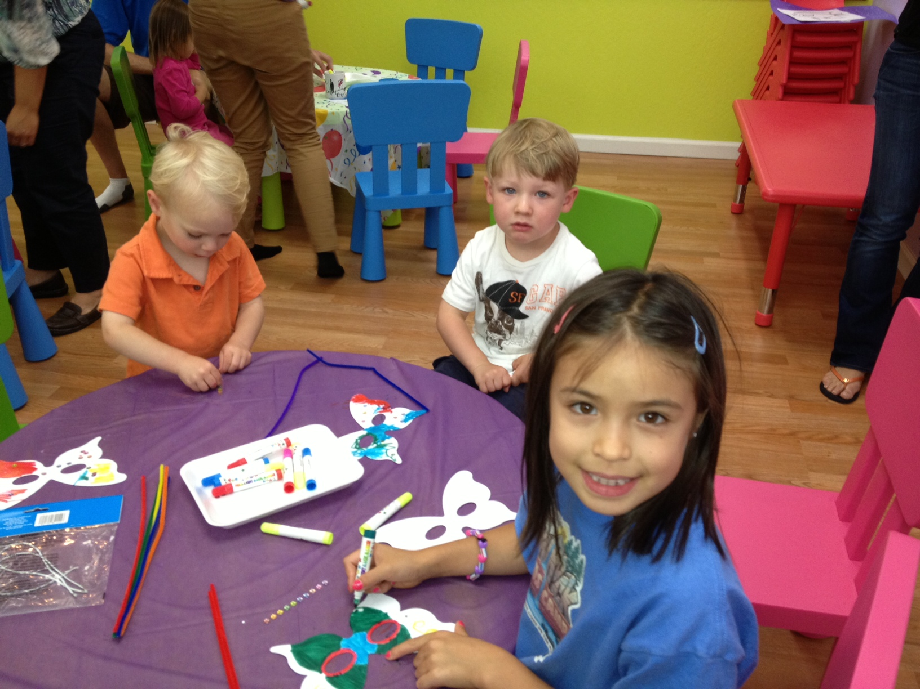
Figure 6.
Children exploring and experimenting with a variety of materials to make face masks.
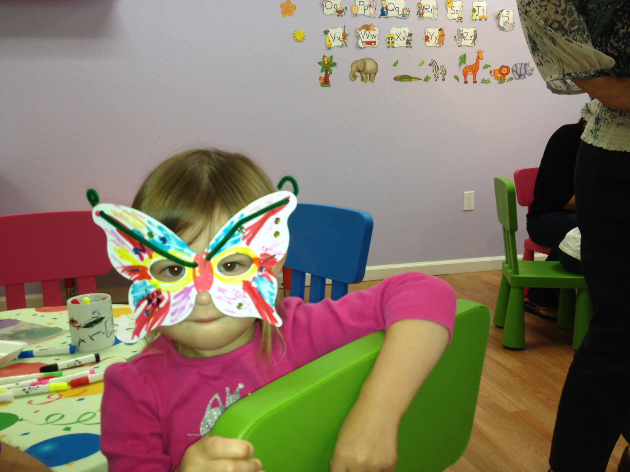
Figure 7.
This shows how this girl made her colorful face mask by using a variety of
materials.

Findings that Art and Creativity are essential in early childhood classrooms
My observations of children in making their artwork and monitoring their engagement, creativity, and interest in owning a piece of work as their own has made me reflect and realize that an art center is essential in all early childhood classrooms. An art center is an area in the classroom where the children do art. The art center is the place where children sit and explore with colors, imagine, and create and express themselves by owning their artwork. An art center should also have a sink for children to wash hands when they are exploring with paint and watercolor. An art center in early childhood classrooms is thus essential and will greatly enhance learning, creativity, and imagination among children and help teachers to keep students motivated and engaged.
Art and Creativity go hand in hand, and they must be at the center of the curriculum during the early years of children’s learning. Having a mini art center or a mini studio in one area of the classroom where children can experiment with colors and explore other materials is important since Art facilitates creativity and imagination. Art also keeps children motivated while they participate in their own learning.
The Values of Art
There are numerous reasons why Art must be at the center of the curriculum during the early childhood period. Art helps children engage in social, emotional, and cognitive development. Teachers must encourage children to use natural resources and recycled materials to create. In Art, this is how creativity comes into play. Children should be allowed to take the lead when doing artwork and the teacher must act only as a facilitator. Educators must also allow children to have ownership of their work. Children should be encouraged to use their hands, fingers, and feet to create artwork since they all help in sensory and motor development. Children’s creativity should be supported by parents at home and by teachers at school.

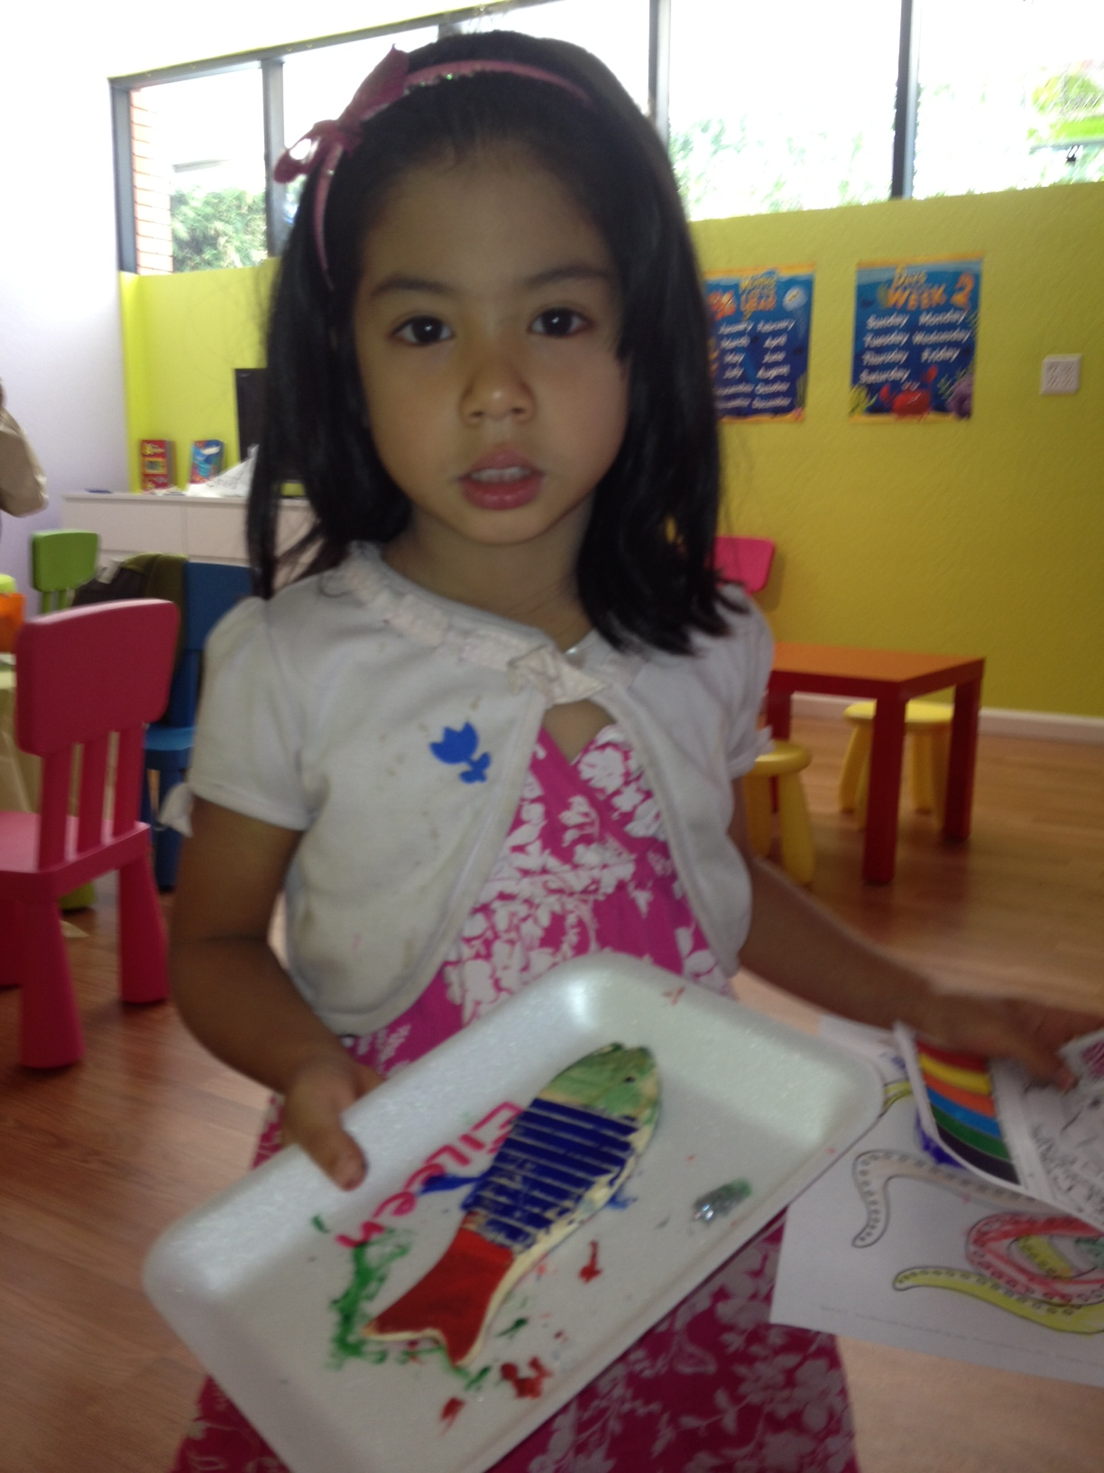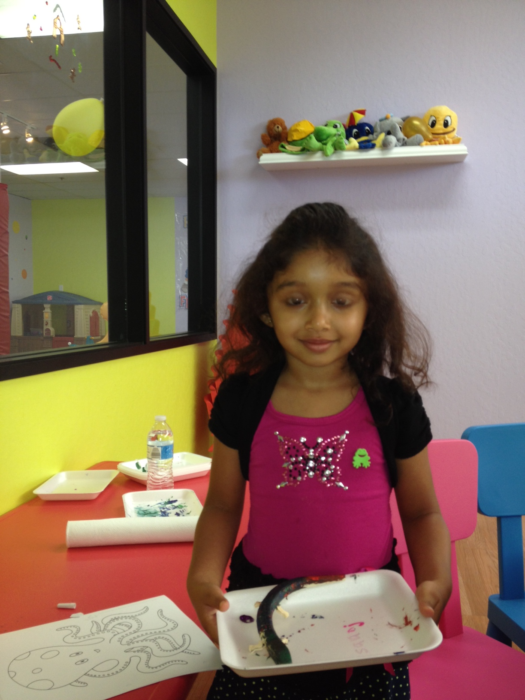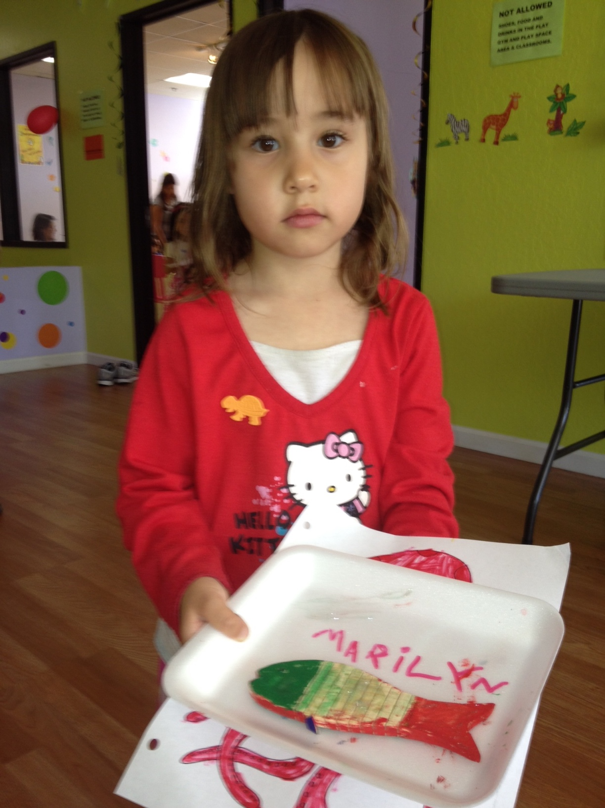

Figure 8.
Shows children taking pride in owning their painting artwork.
Conclusion
In the workshop, I will discuss how to bring out children’s creativity through Art. I will discuss how to facilitate children’s art expressions by using a wide variety of materials. I will also provide a list of items that can be used by participants in their classrooms to conduct Art with children. I will provide information to the participants about how to create art centers in their classrooms. Children do not have to work with only crayons to make Art. When we support children’s freedom to work with a variety of mediums and other natural resources, we allow them to express themselves by using their imagination, which transforms into the Art they make.
According to Robinson (2015), “Imagination is the root of creativity. It is the ability to bring to mind things that aren’t present to our senses. Creativity is putting your imagination to work. It is applied imagination”. I will talk about how we can use a variety of mediums to conduct Art with children from Pre-K through Grade 3, as well as provide examples. I will also show samples of mixed media art options and sensory art, which are especially excellent at building sensory development in young children by making them use their thumbs and fingers. Participants will get opportunities to take away sample lesson plans that they can use to work with children in their classrooms. They will benefit from learning how Art and Creativity should be at the center of every curriculum in early childhood classrooms (Pre-K -3).

References
Prentice, R. (2000). Creativity: a reaffirmation of its place in early childhood
education. The Curriculum Journal, 11(2), 145–58.
Robinson, K. (2015). Creativity Is In Everything, Especially Teaching. Retrieved from
https://ww2.kqed.org/mindshift/2015/04/22/sir-ken-robinson-creativity-is-in-everything-especially-teaching/

